1. **Dataset**
   1. **World Bank Global ID4D Dataset**
      1. <https://id4d.worldbank.org>
      2. The **Global ID4D Dataset**, compiled by the World Bank Group’s Identification for Development (ID4D) initiative, provides a global estimate for the number of individuals **without proof of legal identity**. This document presents: 1.Quantitative data on the number of individuals without access to proof of legal identity split by country, region, and income level; 2.Qualitative data on the entities charged with identification & civil registration (CR); the status of enabling legal and regulatory frameworks; and ICT, e-government, and poverty indices to allow for additional analysis.
      3. The **Global ID4D Dataset**, based on official figures from ID authorities, voter registration, and UNICEF birth registration data

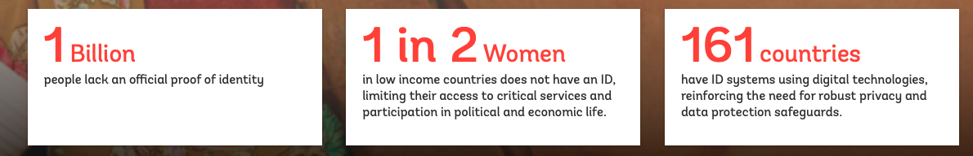  
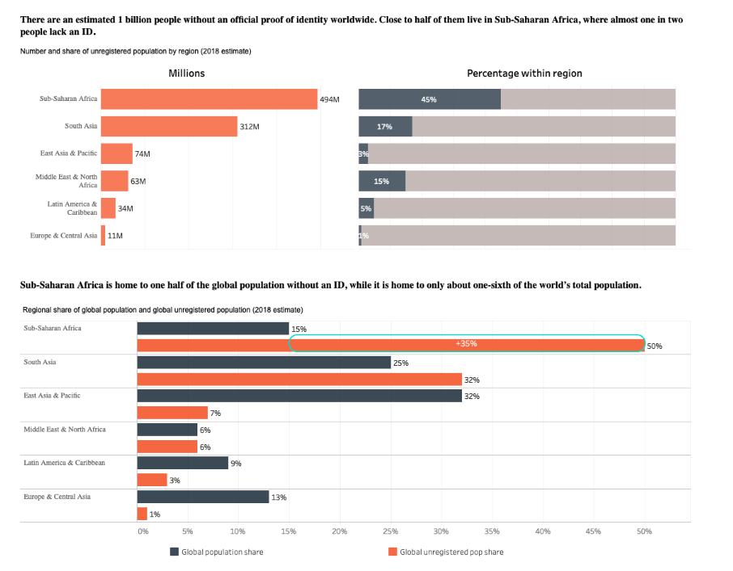

* 1. **Global Findex Data**
     1. <https://globalfindex.worldbank.org>
     2. The Global Findex database is the world’s most comprehensive data set on how adults save, borrow, make payments, and manage risk.The data are collected in partnership with Gallup, Inc., through nationally representative surveys of more than 150,000 adults in over 140 economies. The 2017 edition includes updated indicators on access to and use of formal and informal financial services. And it adds new data on the use of financial technology (fintech), including the use of mobile phones and the internet to conduct financial transactions.
  2. **openAFRICA**
     1. <https://africaopendata.org>
     2. Open source data
  3. **OpenDataForAfrica**
     1. <https://dataportal.opendataforafrica.org>
     2. Various data by topics:
     3. 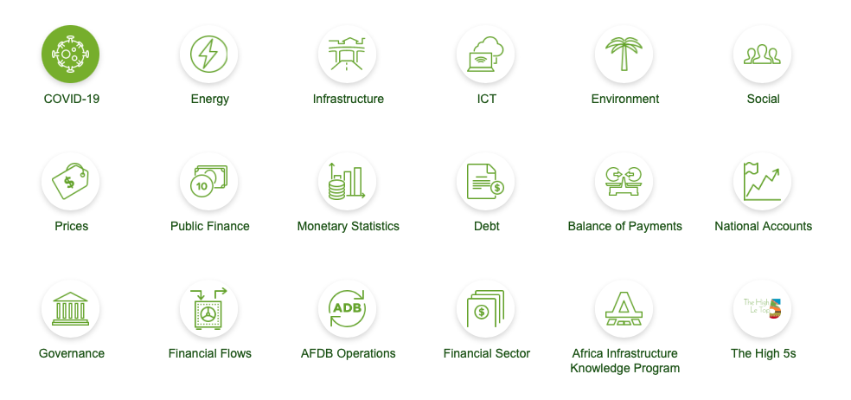

1. ***API***
   1. **MOSIP**
      1. <https://mosip.io>
      2. Open Source Platform for national ID
   2. **ID4Africa**
      1. <https://id4africa.com>
      2. A Movement that promotes the responsible adoption of modern digital identity systems as drivers of socio-economic development
   3. **Africa Open Data**
      1. <https://africaopendata.org>
   4. **Open Data For Africa**
      1. <https://dataportal.opendataforafrica.org>
   5. **Nigeria - National Identity Management Commission**
      1. <https://nimc.gov.ng/verification-service-api/>
   6. **South Africa PBVerify**
      1. <https://pbverify.co.za/integrate-with-our-apis-2/>
   7. **Smile Identify**
      1. <https://www.smileidentity.com>
      2. <https://medium.com/smileidentity/smile-id-web-api-d607f17a1e5c>
      3. Artificial intelligence and identity verification tools have been specially designed for African faces and identities.
2. ***Social Network API***
   1. Twitter API <https://developer.twitter.com/en>
   2. Facebook API <https://developers.facebook.com>
   3. Instagram API <https://developers.facebook.com/docs/instagram-api/>

